1. ReactJS-HOL

**Solution:**

1. To create a new React app, **Installed Nodejs and Npm** from the following link:   
 <https://nodejs.org/en/download/>

2. **Created a React Application** with the name of “**myfirstreact**”, type the following command:

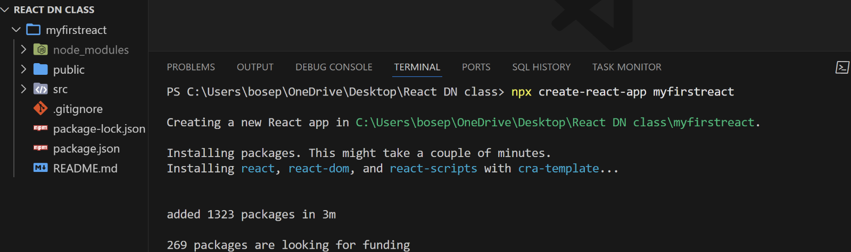 **npx create-react-app myfirstreact**

3. Once the App is created, navigated into the folder of myfirstreact by typing the following command:  
 > **cd myfirstreact**

4. Opened the folder of myfirstreact in Visual Studio Code

5. Opened the App.js file in Src Folder of myfirstreact

6. Removed the current content of “App.js”

7. Replaced it with the following:

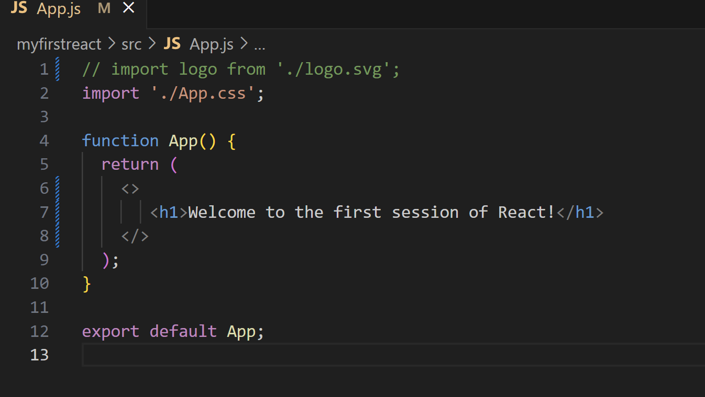

8. Run the following command to execute the React application: myreactapp> **npm start**

9. Opened a new browser window and type “**localhost:3000**/” in the address bar, the rendered page (output) is shown below:

